**Definition: Create design using various plugins in Figma like, iconify, Unsplash, gradient and wave plugins.**

**Solution:**

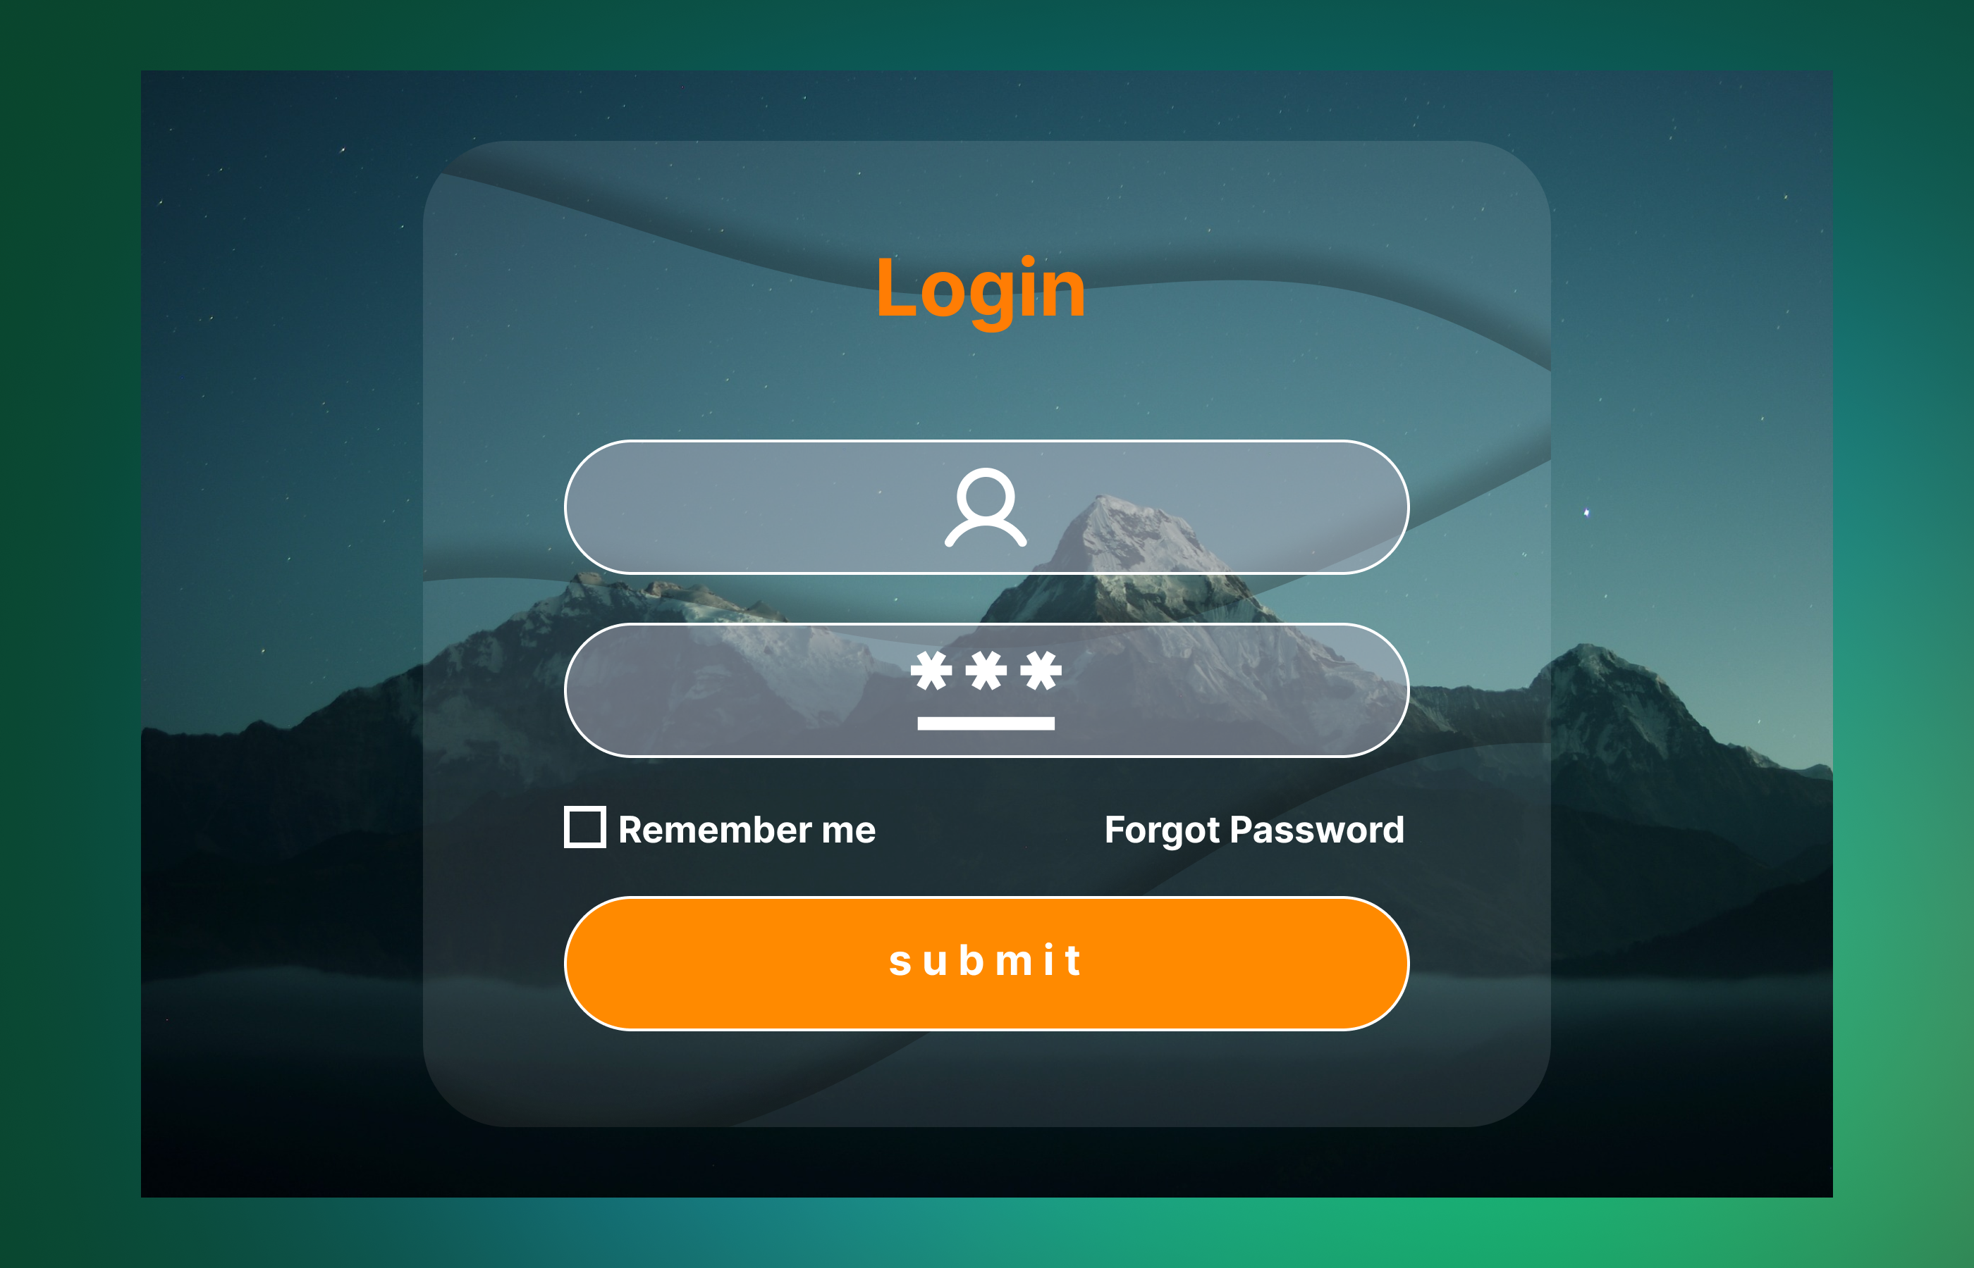

**Steps:**

* First Open Figma in browser mode.
* Then create the new document **File à New Figma Design.**
* Now add one frame using the Frame tool with width=”**700 px”** and height=”**450 px”** on your canvas give color by using **Noisy Gradient** plugin.
* Take an Image of width=”**600 px”** and height=”**400 px”** from **Unspalsh plugin**.
* Now add another frame of width=”**400 px”** and height=”**350 px”** and opacity=**”10%”**, place wave of opacity=**”1%”**, effect Drop shadow and blur=”**10**” by using **Get Wave** plugin.
* Take the text tool and write “**Login**” of font=”**28**” and colour “#**FF7D04**”.
* Take One Rectangle width=”**300px**” & height=”**50px**”, colour=“#**AAABBB**” and opacity=**”50**%”. in the rectangle take an icon of **User** from Iconify.
* Below that rectangle take another Rectangle width=”**300px**” & height=”**50px**”, colour=“#**AAABBB**” and opacity=**”50**%”. in the rectangle take an icon of **User** from Iconify.
* Now take the text tool and write “**Remember me**” of font=”**13**” and colour “#**FFFFFF**”.
* Beside that text box take another one and write “**Forgot Password**” with the font=”**13**” and colour “#**FFFFFF**”.
* Take One Rectangle width=”**300px**” & height=”**50px**” and colour is “#**FF7D04**”. in the rectangle take a text tool & write “**Submit”** with the colour “#**000000**”.
* Now, Go to the **Export** button in the property panel. And **Export** it with .**JPG/.PNG** format.